A Brilliant Blueprint of Larry Brilliant – A Hindu spiritual seeker, physician and Social Engineer
- Ram Kamal

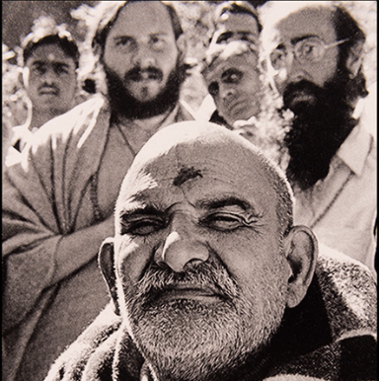
This is the season of Neem Karoli Baba. All the media, be it print, television, social media and the AI news feeds are showing the story of Neem Karoli Baba and at the same time, those atheists and leftists (not all leftists are atheists) whirl a question that, what all these Baba’s does for humanity other than making wealth? The story of Larry Brilliant and his transformation is one of the answers for above such questions, and the biopic Hanuman Ansh also narrate Why Neem Karoli Baba was different.
Larry Brilliant (left) with Neem Karoli Baba
Larry Brilliant often jokes that he doesn’t quite live up to his surname. Yet, a retrospective of his life reveals a trajectory that is nothing short of remarkable, a masterclass in social engineering that bridges the countercultural revolution of the 1960s with the boardrooms of modern corporate giants. From traversing the San Francisco hippie scene to standing at the forefront of global disease eradication, Larry has spent decades architecting systemic solutions for humanity’s most pressing vulnerabilities.
Being a social engineer, for quite some time I am following Larry and his Psychedelic Prelude, Alter Senses and wandering in the Ashrams of India to realise who am he. Before he became a leading epidemiologist and a pioneer of corporate philanthropy, Brilliant was a young doctor with few months of house surgency experiences in the United States and found himself wandering through the Himalayas in a psychedelic van with his Hippe friends. Having travelled to India alongside his wife, Girija, to work on a film (the famous “Hare Rama, Hare Krishna” Hindi Block buster), he eventually settled in the Kainchi ashram under the guidance of the spiritual teacher Neem Karoli Baba.
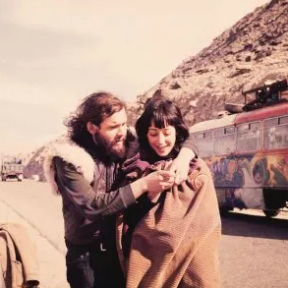
It was here that a profound transformation occurred. His guru unceremoniously challenged Brilliant’s identity as a wealthy American doctor, declaring that true medical work meant serving the masses. The mandate was clear: go to the World Health Organization (WHO) in Delhi and help eradicate smallpox and become an UN Doctor to serve the world. Equipped with little more than a long kurta and flowing hair, Brilliant was initially turned away from the WHO offices over a dozen times before being hired to work as a typist. Larry wandering Himalayas on a Psychedelic Van with his
wife Girija as a Hippe
This unlikely entry point propelled him into one of the greatest feats of mass social engineering in medical history. Smallpox was a scourge that claimed half a billion lives in the 20th century alone. Defeating it required more than just medical intervention; it demanded an unprecedented mobilization of human capital and rigorous public health strategy. Alongside 150,000 Indian health workers, Brilliant participated in a campaign that involved knocking on every single door in India—two billion house calls in total—eventually cornering and eliminating the virus. Brilliant frequently deflects personal credit for this triumph, instead highlighting the unsung local heroes, the thousands of Indian doctors and health workers who bypassed promotions and sacrificed their personal lives to achieve the impossible.
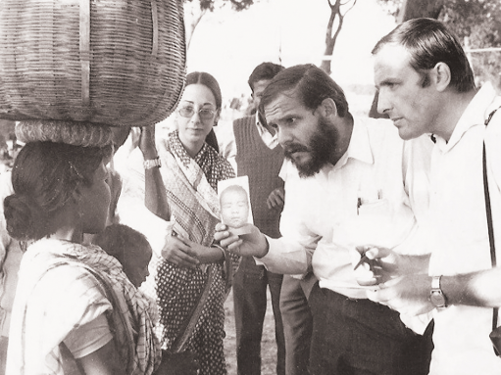
Following the eradication of smallpox, Brilliant’s journey seamlessly transitioned from the rural villages of India to the burgeoning tech hub of Silicon Valley in America. Here, his knack for building systems found a new canvas. He recognized early on that the technological revolution could be harnessed to dismantle systemic barriers to health and accessible education beyond the Government red tapes.
In the search of Smallpox

While still at the ashram, Brilliant had crossed paths with a young, barefoot traveller named Steve Jobs. Years later, as Jobs built Apple, Brilliant sought his support to create an organization modelled on the smallpox campaign, but this time targeting preventable blindness and ensuring those with visual challenges could lead independent, empowered lives.
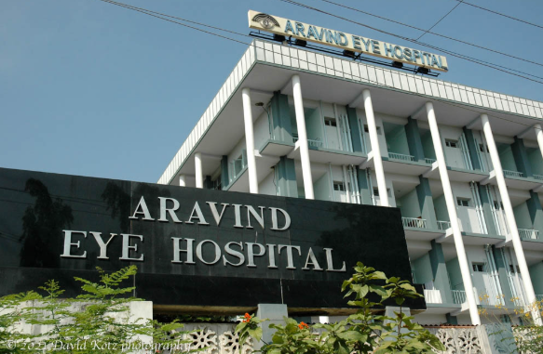
With seed funding and early computer technology from Jobs, Brilliant co-founded the Seva Foundation. This initiative brought critical eye care to the developing world and provided instrumental support to Dr. G. Venkataswamy (later Padmabushan recipient) in scaling the Aravind Eye Hospital in Madurai. Today, Aravind stands as the largest and most efficient eye hospital in the world. Not only by treating visual impairment not just as a medical issue or prevention, but as a barrier to social equity, Seva has helped restore sight to over four million individuals globally and trained 1000s of doctors from developing countries in the modern nuances of ophthalmic surgery. This enduring support for the blind in India demonstrates how inclusive health interventions can completely alter a community's socioeconomic trajectory.
Brilliant’s ability to align corporate giants with social causes didn't stop with Apple. When Larry Page and Sergey Brin founded Google, they envisioned a company that would embed philanthropy into its very DNA. Brilliant was tapped as the inaugural Executive Director of Google.org, tasked with operationalizing an ambitious pledge: with an equation of 1:1:1 by dedicating 1% of Google’s equity, 1% of its profits, and 1% of its employee time to global social impact. Under his stewardship, Google.org deployed nearly a quarter of a billion dollars to combat global poverty, address climate change, and build early warning systems for pandemics. He effectively engineered a model where corporate wealth and technological prowess were redirected toward the benefit of the world’s most vulnerable populations.
He then thought of confronting tomorrow’s global threats. He evolved the architecture of global risk, and Brilliant’s focus has shifted accordingly to create platforms to counter it. Moving from his role at Google, he assumed the leadership of the Skoll Global Threats Fund—established by eBay co-founder Jeff Skoll. In India often discussed in broader philanthropic circles alongside allied empowerment initiatives like the Score Foundation in India for the empowerment of Blind is his direct institutional leadership here was with Skoll.
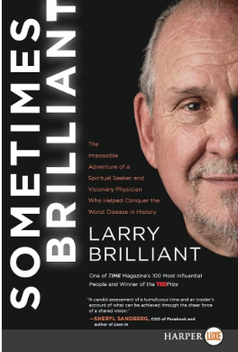
At Skoll, Brilliant was tasked with looking over the horizon to identify and mitigate the existential crises that could unravel decades of social progress. He identified five primary global threats: catastrophic pandemics, climate change, water scarcity, unchecked nuclear proliferation, and regional conflicts in volatile areas. Brilliant understands that these issues do not exist in isolation. The melting of the Himalayas, for instance, exacerbates water disputes between superpowers, creating a cascading matrix of risk.
His current work is a culmination of a lifetime spent engineering networks of resilience. Whether he is advising world leaders on pandemic preparedness, a threat he viscerally understands, having served as a senior technical advisor for the highly prescient film ‘Contagion’ or championing the grassroots efforts of Rotarians in the fight against polio through his Oscar-nominated documentary ‘The Final Inch’, Brilliant remains committed to systemic, inclusive solutions.
Larry Brilliant’s career is a testament to the power of combining deep empathy with strategic public health campaigns. He proves that the idealism of the 1960s counterculture can be translated into hard metrics: viruses eradicated, sight restored to millions, and corporate billions diverted to the underserved.
By forging alliances across seemingly disparate worlds, from Himalayan mystics to tech billionaires, and from local Indian health workers to global policymakers, he has created accessible blueprints for combating the world's most intractable problems. While he may humbly joke about his name, his life’s work in universally accessible healthcare, disease prevention, and empowering the visually impaired remains, unequivocally, brilliant.
#neemkarolibaba #larrybrilliant #stevejobs #who #google.org #aravindeyehospital

Aravind Eye Hospital, India’s largest chain with the mission of “eliminating needless blindness”.

