You’re the Cure Series – Food 2

Rewiring Mind for Diet and Habit Reversals

Ram Kamal
Here I am triggering a thought-provoking conversation to unpack the profound interconnectedness of mental programming, community, biochemistry, and physical health. 90% of the present-day hospitalisation happening due to lifestyle triggered illness. The central to reverse this illness and to design an enjoyable healthy lifestyle change, medicines and medications merely manage numbers. The true disease reversal demands a lifestyle transformation rooted in consciousness, that helps to secure a healthy diet and affordable habits.
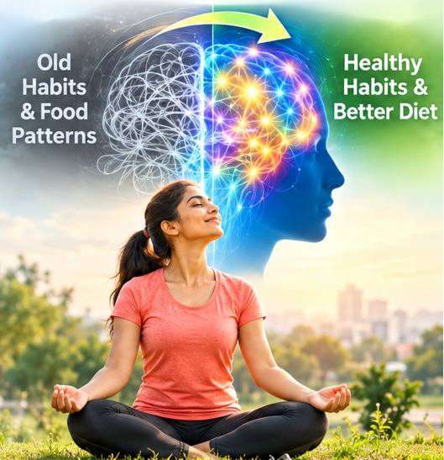
1. Breaking Free from the "Lifelong Disease" Belief (Sanskars) Plays Big Role.
- The Biology of Belief: Majority conventionally made to believe due to the present-day medical and commercial lifestyle information available from all sources often instil the belief that hypertension, diabetes, and cholesterol require lifetime medications. I am not rewiring these false beliefs. Yes, initially we need medicine to take control of the spike, but unless we change our diet and habits, dependency to medicine will stay forever.
- Rewiring Habits: Yes, we need to understand and rewire our habits. As all you agree, our thoughts lead to decisions, which become actions, eventually forming ingrained impressions (sanskars). When an action enters autopilot, we stop acting with awareness. Changing these beliefs requires experiential proof from their lifestyle and food habits to make people see their blood sugar drop dramatically in just days, their willpower to shift their lifestyle soars. I call this as the information infused change results.
2. The Roots of Metabolic Dysfunction
- Chronic Caloric Excess & Organ Fat: The conditions like Type 2 diabetes often stem from years of eating slightly more than the body burns. Even a single gram of excess visceral fat in the 100-gram pancreas can trigger insulin dysfunction, while 100–200 grams in the liver drives fatty liver and elevated glucose production. The first lesson is’ what you eat and what its caloric value and how much you consumed by that day’.
- The Power of Fasting: Fasting gives organs the chance to metabolize stored fat reserves. A structured, well-hydrated intermittent day fasting model helps induce ketosis, curb hunger signalling, and break the primal fear of starvation.
- Eliminating or minimalizing Dairy: The presence of IGF (Insulin-like Growth Factor) molecules in commercial milk and dairy products frequently interferes with insulin reception; removing dairy often triggers rapid improvements in blood sugar regulation. This is a major challenge for we Indians. But we can reach to the goal by minimalizing the minimal with double toned produces to reach the elimination goal.
3. The Neurochemical Symphony: Moving from Dopamine to Serotonin
Modern lifestyle traps often hijack brain chemistry:
- Dopamine vs. Serotonin: Dopamine drives quick spikes from scrolling, bingeing, or shopping, leading to subsequent crashes and cravings. In contrast, serotonin fosters a calm, centred, sustainable contentment. Morning sunlight exposure, physical rhythm, and mindful routines naturally elevate serotonin levels. For the work, I need to glue to the glasses for more than 8 to 10 hours, but I framed my mind to stay away from bingeing and to satisfy the urge with fruits and steamed vegetables, instead of modern dopamine spiking foods to serotonin releasing food. I try to eat protein with healthy carbs like whole grains, fruit, or vegetables. Carbs help release a bit of insulin, which clears other amino acids from your blood and lets tryptophan reach your brain more easily.
- Hunger Regulators (Ghrelin & Leptin): Disrupted circadian rhythms and chronic stress misfire appetite signalling ghrelin (hunger) spikes unnecessarily while leptin (satiety) fails to register fullness. Ghrelin is the under promoted hormone, that is made by your stomach. Ghrelin is mainly known for that pang of hunger you feel when you haven’t eaten in a while. But ghrelin is a hormone of many functions. It also signals your body to release other hormones and protects your cardiovascular health. Scientists are still learning about all the ways it affects your body. Taming the Ghrelin Hormone has several other key functions, it promotes storage of body fat, makes our pituitary gland release growth hormone, makes your digestive system move food from your stomach through your small and large intestines, it helps control insulin release, triggers our pancreas to release glucagon (here mindful eating plays a crucial role to keep glucagon at bay).
Ghrelin also plays a role in:
Protecting your cardiovascular health, Learning and memory, Stress, Mood and anxiety and Sleep-wake cycle (circadian rhythm).
- Sleep and Inflammation: Chronic elevation of hs-CRP (High-Sensitivity C-Reactive Protein) is directly tied to poor sleep. As a cultivating habit, putting screens away by 9:30 PM and sleeping by 10:00 PM restores cortisol and melatonin balance, serving as the body's most potent anti-inflammatory therapy.
4. Psychological Traps: The Danger of Extreme Optimism
While chronic pessimism breeds stress and anxiety, in other hands unrealistic optimism can be equally dangerous. It took a long time for me to understand, I am person with extreme optimism, and it caused a lot of damaged to my health unknowingly.
- People who think "Nothing will ever happen to me" frequently neglect regular monitoring, ignore dietary limits, and rationalise poor health markers.
- The goal is realistic optimism—staying positive while taking disciplined, evidence-based care of one’s physical vehicle.
5. Epigenetics, Community Energy, and Service (Seva)
- Genetics Loads the Gun, Lifestyle Pulls the Trigger: Genes represent potential, but day-to-day choices, emotions, and stress levels dynamically switch inflammatory pathways on or off.
- The Power of the Collective: Undertaking diet and health overhauls alone often encounters friction and isolation. When people gather in groups to fast, meditate, or share progress, the collective energy dramatically lowers individual effort and fosters accountability. This is the power of religious fasting rituals. This article comes at the time of Dussehra 9 day fasting. I request all communities, clubs and associations should plan a day get-togethers every two weeks precisely to take affirmations and exchange their experience in their undertook diet and health overhauls between the members.
- Selfless Service: Engaging in genuine, selfless contribution, whether mentoring newcomers on healthy habits, diet or providing emotional care triggers oxytocin (the connection and healing hormone). It elevates emotional stability and directly shields cardiovascular and metabolic health. Please join the Punyya Health Volunteer Program to do a community Health Seva to reap the benefits of Seva triggered oxytocin and happiness.
Move to Making Daily Micro-Decisions
Reversing disease through diet and habits are not about sporadic, monumental achievements. It is shaped by consistent micro-decisions such as turning off devices at night, choosing fibre over processed snacks, prioritizing an early morning walk, and maintaining inner calm amidst life’s inevitable crises. By aligning our thoughts, emotional health, diet and daily rhythms, vibrant health becomes a natural consequence rather than an elusive goal.

